Integrate AngelScript Compiler to Code::Blocks IDE.

- Copy lexer_angelscript.xml to Program Files\CodeBlocks\share\CodeBlocks\lexers.
- Run CodeBlocks.
- Go to Tools -> Configure Tools…
- Press Add button.
- Type Name, Executable, Parameters, Working directory, Launching options (Pic 1).

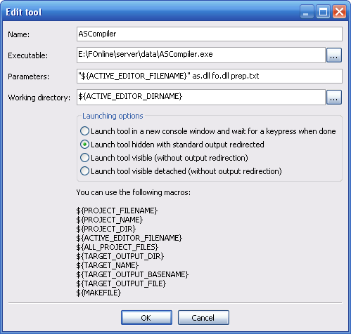
Pic 1

- Go to Settings -> Environment… -> Files extension handling.
- Press Add and type “*.fos”, than OK and OK again.
- Run code_blocks_fos.reg.

For run compiler on hotkey, than look in Editor… -> Keyboard shortcuts, Tools -> ASCompiler, New short cut (I bind it on F7 key).

